Identification of Unknown Sample B
Jacey Cochran
11/28/2023
Chem 2081-003

Introduction
The goal of this Formal lab report is to determine the structure and formula of unknown sample B, using three spectra analysis tests. The unknown sample was interpreted and identified using Infrared Spectroscopy, Gas Chromatography and Mass Spectroscopy, and Nuclear Magnetic Resonance. The three chemical tools gave a thorough analysis of the types of chemical bonds, chemical weight, and chemical structure of the unknown compound presented. Through analysis utilizing these crucial chemical tests, compounds in any unknown sample can be tested and interpreted to help scientists confirm or identify a substance. This skill is crucial because it allows professionals in various fields like healthcare, engineering, and agriculture to keep our communities and environments healthy and safe by being able to monitor the presence of both beneficial and harmful chemical compounds.
Body
Chemical analysis is the study and use of instruments that help scientists identify and qualify matter. The principles of chemical analysis are sampling, field sampling pre-treatment, laboratory treatment, laboratory assay, calculations, and results presentation. The three chemical tools used today are an important part of the chemical analysis process.
Nuclear Magnetic Resonance is used to confirm the molecular structure of the unknown compound. NMR is utilized by observing and measuring the interactions of the nuclear spins upon certain atomic nuclei. When the compound is present within a magnetic field and irradiated with light, information can be gathered on how the light interacts with the compound. While in the magnetic field, the magnetic moments exhibited free induction decay. Free induction decay is a time domain signal that is converted to a set of frequencies. The decay is transformed and read as an NMR spectrum. The NMR spectrum begins on the far-right side with a reference peak, known as tetramethylsilane. Tetramethylsilane (TMR) is known as the universal reference standard for NMR. NMR has three components that are critical when interpreting a graph: the chemical shift, integration, and splitting. Chemical shifts are the location of the peaks on the spectrum. A peak in the graph can be located “up-field” or “down-field.” The chemical shift gives us an indication of the chemical environment of a particular hydrogen atom in a molecule. The closer the targeted proton is to an electronegative atom the greater the de-shielding effect that will occur. The de-shielding effect causes the protons to be pulled away from the nucleus and as a result be more “down-field” on the spectrum. This gives us good parameters in which to judge where a proton is relative to the most electro-negative atom in the molecular structure. Integration is the area under the curve, which displays how many chemically equivalent protons are generated in the molecule. The is shown through the height of the peaks on the spectrum. Finally, splitting corresponds to the number of neighboring hydrogens another proton has. On the spectrum, peaks can be split into doublets, triplets, and quartets depending on the chemical structures.
Gas Chromatography and Mass Spectroscopy is another chemical tool useful for measuring the mass-to-charge ratio of molecules present in a compound. Mass spectroscopy is done through the ion source being converted into the gas phase through ionization techniques, then sorted by a mass analyzer. The gas phase was introduced into this technique to separate the compounds within a controlled environment. After the separation, the mass analyzer will sort out different variations of the molecule that were deduced in the analyzer depending on the retention time of each molecule. After the sorting, a m/z value (mass-to-charge ratio) is obtained, which corresponds to the molecular weight of the charged compound obtained. The data gathered on the graph displays the atomic weight of the parent molecule, which in turn can help confirm the identity of a particular compound. Mass Spectroscopy can also help scientists detect if a compound is pure or not if they know the starting molecule formula and weight of the sample that they are testing.
Finally, the last spectrum is Infrared Spectroscopy (FTIR.) FTIR contains energy measured as frequency or wavelength along a plotted horizontal axis. The intensity of the absorption is displayed along the plot. Infrared spectroscopy is used for identifying the presence of functional groups. The positions of the absorption bands give good indications of the types of chemical bonds, which allows us to gain insight into the nature of the functional groups in the given compound. When irradiated with specific infrared light atoms can stretch and bend in a vibrating motion. Each motion occurs at a specific energy that varies depending on the functional groups present in the molecule. The different energies of infrared light are located along the x-axis and the transmittance percentage is located along the y-axis. When peaks and dips in a spectrum are observed that indicates that there is a light being absorbed by a particular functional group.
Using these three chemical tools, compounds in samples can be identified down to their structure and formula (Keller 2023).

Data
NMR Sample B Figure:
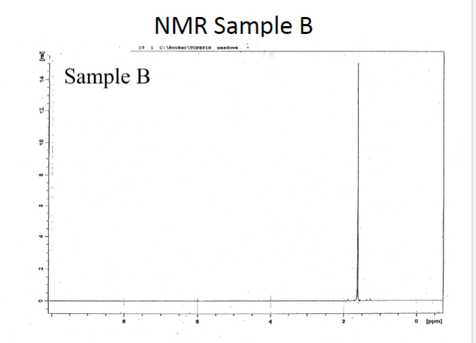

GCMS Sample B Figure: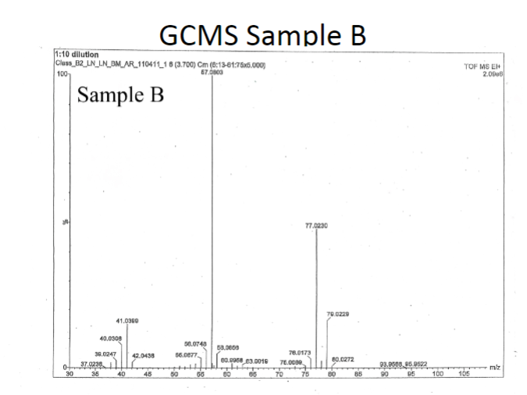

FTIR Sample B Figure:
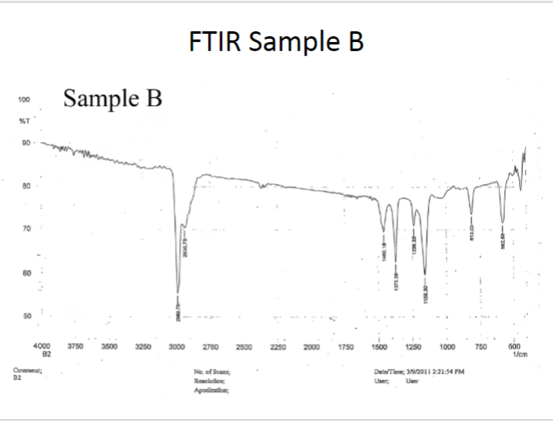

Analysis
On the NMR Sample B spectrum. A singlet was observed around 1.7 ppm. The value is common for a carbon and hydrogen group. Since there is no splitting, we assume the hydrogens are chemically and magnetically equivalent to each other. The location of the peak is located “up-field” from the most electronegative atom. This chemical shift indicates there could be a chlorine atom at the beta position. The singlet is common for a single integration value.
In the GCMS spectra, the highest m/z ratio observed was 95.9522 m/z. Since the highest ratio observed is simply an ion of the parent molecule, and no bonds were cleaved, the molecular weight will be equivalent to that of the predicted compound.
Looking at the FTIR Sample B graph, there are no peaks from 1500-2000 and 2000-2500 cm⁻¹. A peak is noted between the 2900 cm⁻¹ range. The stretch that is present displays that there is a fully saturated carbon, hydrogen bond (sp³ hybridized carbon). The far-right side of the IR graph is the “fingerprint” region, which contains a few notable peaks. There are several peaks between (400-1500 cm⁻¹⁾ that display methyl groups or single bond according to the frequencies. At 813.03 cm⁻¹ and 582.53 cm⁻¹ the peaks show an indication of a halogen, specifically a chlorine atom according to the data given.
Conclusion
Based on the results of the three chemical spectra, NMR, GCMS, FTIR, it can be determined that the chemical formula of unknown sample B is tert-butyl chloride (2-chloro-2-methylpropane). The results from the NMR detected the presence of a carbon-hydrogen bond in upstream from a projected chlorine atom. The FTIR also confirmed the presence of a chlorine atom and confirmed that no double or triple bonds were found in the unknown sample. The large peak on the FTIR displayed an sp³ hybridized carbon. Lastly, the GCMS gave an indication of the projected molecular weight of the compound 95.9522 g/mol. Using the data from above, if the molecular weight of chlorine (35.45 g/mol) and the molecular weight of the confirmed sp³ hybridized carbon (15.025 g/mol) the remaining mass is 45.4772 g/mol. The last part of the puzzle is revealed in the FTIR and the NMR analysis. The FTIR shows that more carbon-hydrogen bonds are present along with the saturated sp³ hybridized carbon. The NMR analysis also hints towards this outcome due to the chemical equivalence of the protons in the compound and the singlet peak present. The remaining compound in the unknown sample must be three carbons and six hydrogens which gives us the chemical formula C₄H₉Cl. This compound is known as tert-butylchloride.

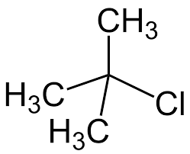

References
Keller L, Joseph K, and Miguel S. 2023 Fall. CHEM 2081 Organic Chemistry II Lab Manual [lab manual]. Auburn (Al): Auburn University.

